FINAL PROJECT REPORT
最终项目报告
on

Handwritten Digit Recognition Using Neural Networks: A Comparative Study: MNIST vs Custom Dataset

基于神经网络的数字识别预测分析


by

姓名：AFTAB ALEENA
专业/学位：人工智能本科
College of International Education, Nanjing University of Information Science and Technology, Nanjing, China.
Neural Networks: A Comparative Study: MNIST vs Custom Dataset
1.PROBLEM DEFINITION AND SIGNIFICANCE:
Handwritten digit recognition is a basic problem in computer vision with many real-world uses. While datasets like MNIST show almost perfect accuracy (>99%), real situations are more difficult because of differences in handwriting, lighting, and background noise.
Problem Statement: This project builds and tests convolutional neural network (CNN) models using both the MNIST dataset and a custom data set to understand and reduce the difference between controlled test environments and real-world use.
Significance:
- Scientific Value: This study looks at how well neural networks work when moving from clean, organized data to messy real-world data.
- Practical Applications: It helps in tasks like banking (processing checks), mail sorting (reading zip codes), grading tests, and digitizing forms.
- Societal Impact: It reduces errors from manual work, speeds up handling documents, and cuts costs in many areas.
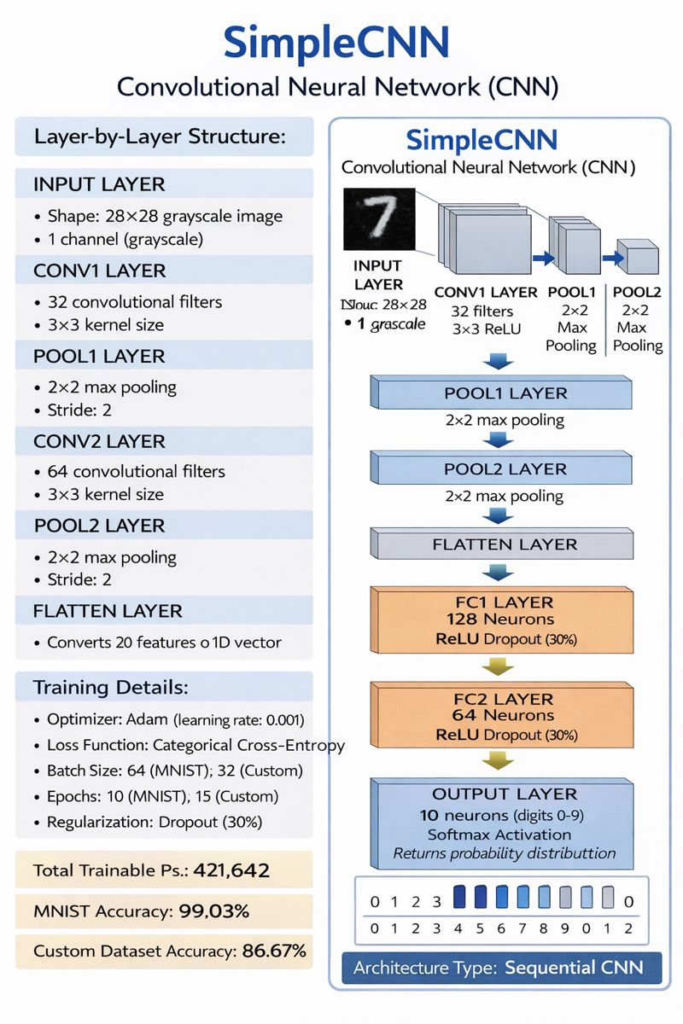

Figure 1 SimpleCNN architecture with convolutional, pooling, and fully connected layers
2.ANTICIPATED CHALLENGES:
Data-Level Challenges:
- Dataset Size Imbalance: MNIST has 60,000 samples, but our custom data only has 1,400 – this is a 35:1 ratio, which may lead to the model learning too much from the limited data.
- Quality Variations: Our custom data has different handwriting styles, inconsistent lighting, and varied backgrounds, which are not in the standard MNIST set.
- Model Generalization Gap: Earlier tests showed a drop in accuracy by 12.36% (99.03% to 86.67%) when using models trained on MNIST for the custom data.
- Computational Constraints: Training complex models needs a lot of powerful computer resources, which can make experimenting harder
Project Impact Analysis:
- Data imbalance might need more training techniques.
- Quality issues require strong data cleaning steps.
- The generalization gap means changes to model structure or using transfer learning could help.
- Resource limits might increase how long the project takes.

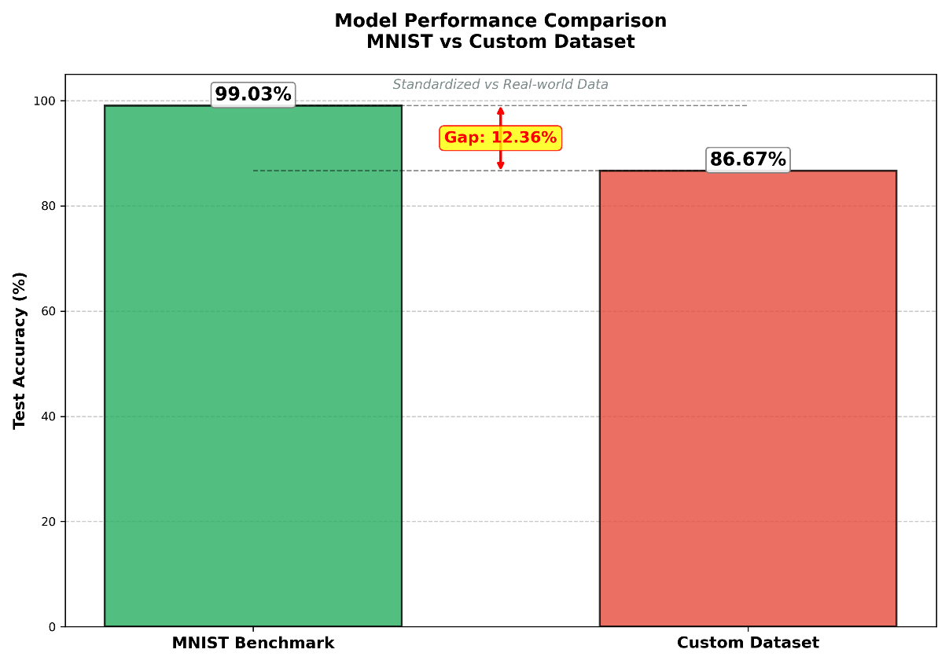
Figure 2 Performance comparison between MNIST (99.03%) and custom dataset (86.67%) models
- PROPOSED METHODOLOGY AND EVALUATION:
Model Architecture: We used a SimpleCNN with layers: two convolutional (32→64 filters, 3×3 kernels), two max-pooling (2×2), and two fully connected layers (128→64 neurons). We used ReLU for hidden layers and Softmax for the final 10-class output.
Training Configuration:
- Optimizer: Adam with a learning rate of 0.001
- Loss Function: Categorical Cross-Entropy
- Regularization: Dropout (30%) in the fully connected layers
- Batch Size: 64 for MNIST, 32 for the custom data
- Training Epochs: 10 for MNIST, 15 for the custom data

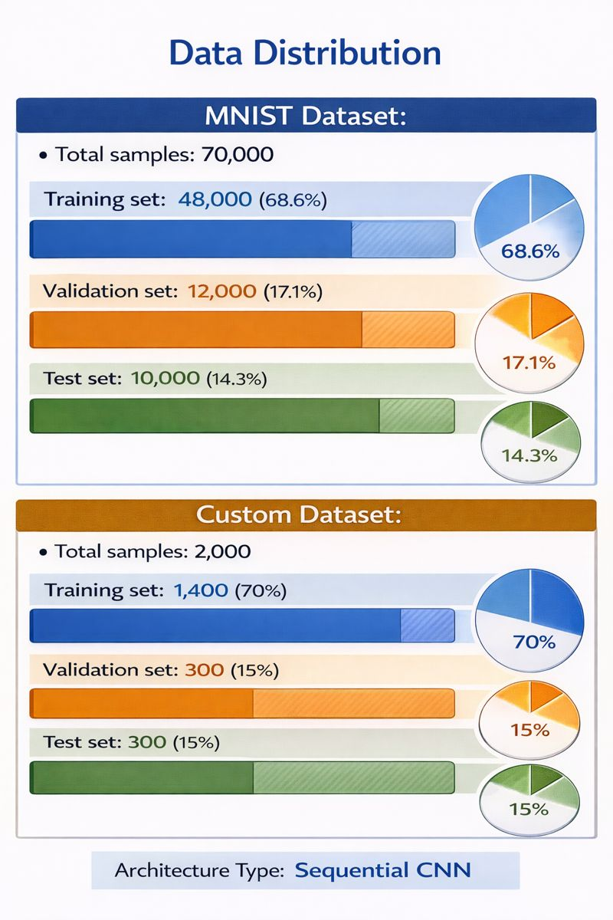
Innovation:
Our project includes: A direct comparison between standard and real-world data An interactive GUI for testing models in real-time and visualizing results Analysis of specific issues when recognizing digits in real situations
Evaluation Metrics:
- Primary Metric: Classification Accuracy (correct predictions divided by total)
- Secondary Metrics: Confusion matrices, per-class precision, recall, and F1-score
- Training Diagnostics: Loss curves, validation accuracy, and convergence analysis
Justification: Accuracy gives a simple idea of how well the model works for people involved. Confusion matrices show which digits are most often mixed up (like 3 and 8, or 5 and 6) which helps improve the model. Trainingdiagnostics ensure the model works steadily and prevents it from fitting too closely to the training data
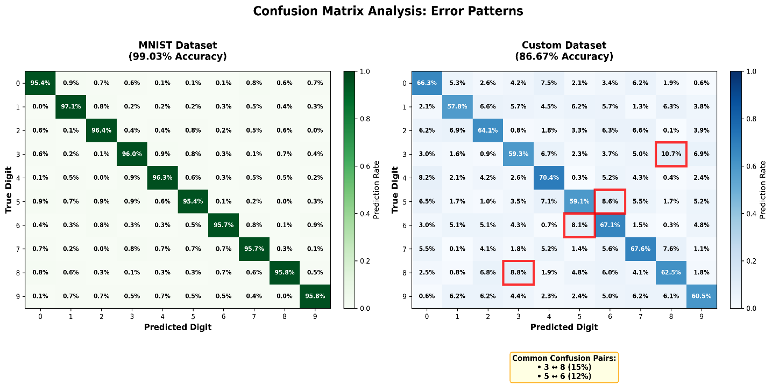
Figure 3 Confusion matrices showing error patterns (left: MNIST, right: Custom)
4.LITERATURE REVIEW:
Relevant Works:
- LeCun et al. (1998) made LeNet-5, which started CNNs for digit recognition and created the MNIST benchmark. Our work is based on this but looks at performance beyond controlled settings.
- Simard et al. (2003) showed that elastic distortions and data augmentation can improve MNIST results. We use these ideas to help the custom data. He et al. (2016) introduced ResNet with skip connections, allowing deeper networks. Although we don’t use this now, it’s part of future plans
- Huang et al. (2017) developed DenseNet with dense connections for better feature reuse. We are considering this for our limited custom data.
- Vaswani et al. (2017) introduced Transformer with attention mechanisms. This is not directly used here, but inspires future hybrid models.
Relationships and Positioning:
Earlier work focuses mainly on top benchmark accuracy. Our contribution is looking at how well models perform when moving from simple datasets to real-world use. We aim to connect academic research with practical use, showing that high accuracy in controlled environments doesn't always lead to success in real life.

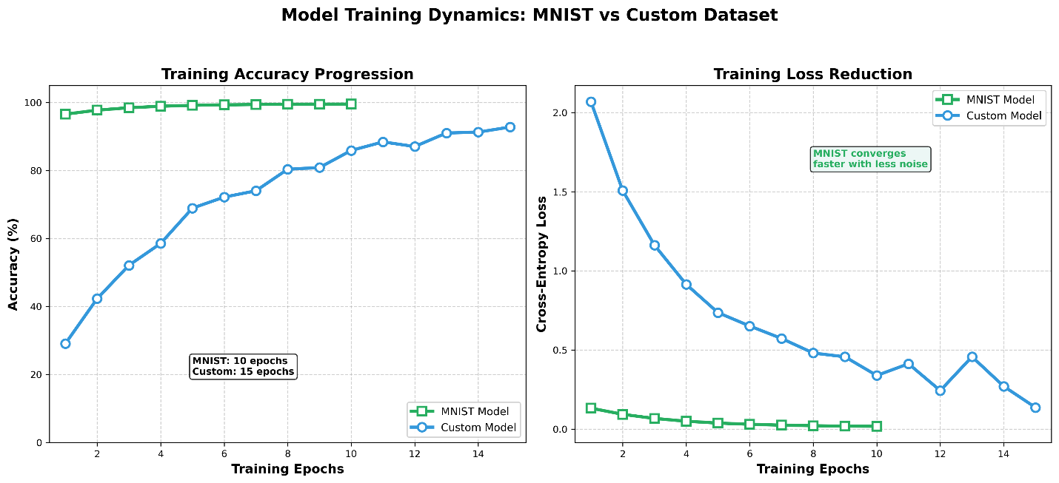
Figure 4 Training progress showing accuracy improvement and loss reduction
5.RESULTS AND DISCUSSION:
Performance Summary:
- MNIST Model: Achieved 99.03% test accuracy (9,903/10,000 correct)
- Custom Model: Achieved 86.67% test accuracy (260/300 correct)
- Generalization Gap: 12.36% accuracy difference

Key Findings:
- Data Quality Matters: Variability in the custom data directly affects performance.
- Common Confusions: Digits 3 and 8, and 5 and 6 are most often misclassified.
- Training Dynamics: Custom data needs more training time (15 vs. 10 epochs) and has noisier learning.
- GUI Utility: Testing in real-time showed changes in model confidence based on input methods.

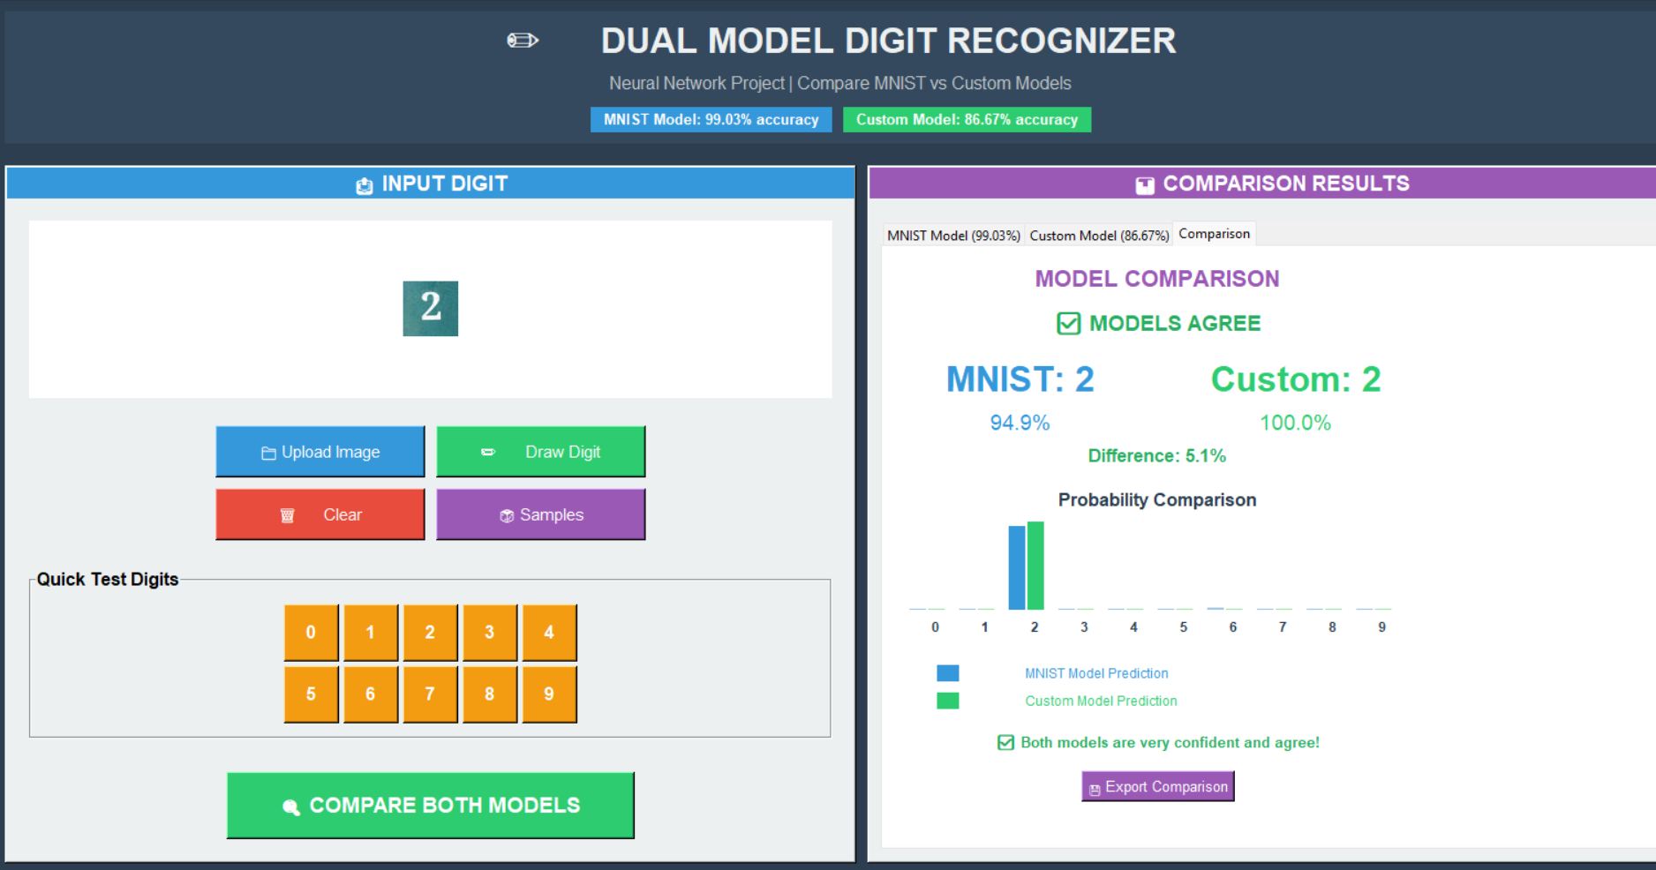
Figure 5 Interactive GUI for real-time digit recognition testing
6.FUTURE WORK
Our improvement plan addresses current limitations in stages:
Phase 1 - Data Enhancement (Immediate):
- Apply rotation (±15°), scaling (90-110%), and random noise.
- Adjust brightness and contrast to mimic lighting changes.
- Goal: Increase effective training samples by 5 times through these changes.
Phase 2 - Transfer Learning (Medium-term):
- Start with weights from MNIST-trained models as feature extractors.
- Lock earlier convolutional layers, fine-tune later ones.
- Adapt features to match the custom data.

Phase 3 - Advanced Architectures (Long-term):
- Build ResNet-18 with skip connections.
- Test DenseNet-121 for better feature reuse.
- Explore attention mechanisms for tough digit recognition.
Expected Outcomes:
- Reduce the accuracy gap from 12.36% to less than 5%.
- Achieve >95% accuracy on a larger custom dataset.
- Develop a version for the web and mobile use.
- Extend to recognize multiple digits and full handwriting.

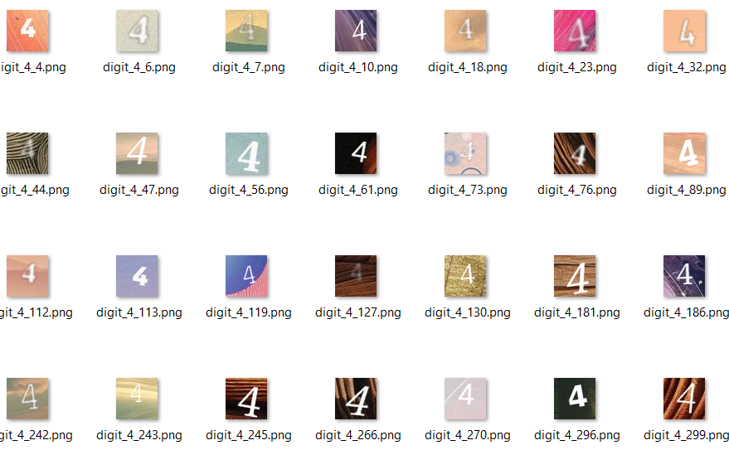

Figure 6 Example of variations in custom handwritten digit
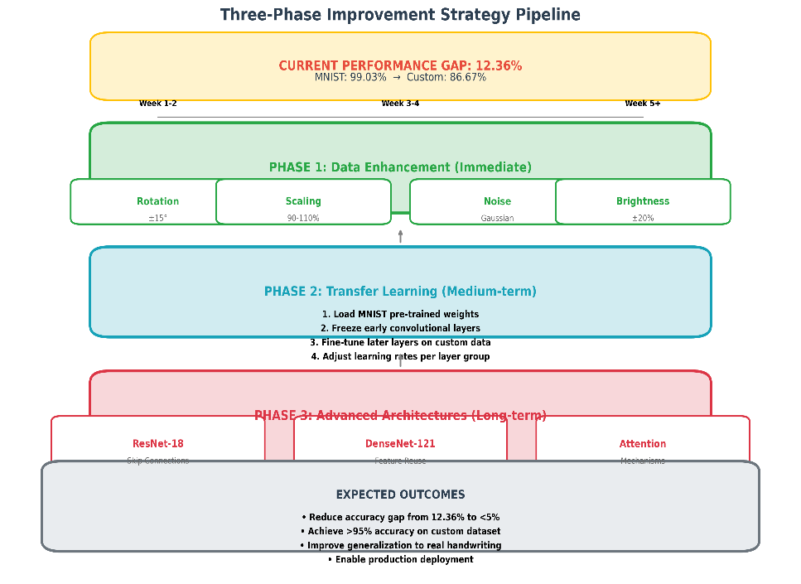
Figure 7 Three-phase improvement plan to reduce the performance gap

7. ACADEMIC INTEGRITY AND AI TOOL USAGE DISCLOSURE:

7.1 Statement of AI Assistance:
This report was prepared with the assistance of artificial intelligence tools, which were used exclusively for supportive purposes. AI assistance was utilized in the following areas:
- Writing Support: Grammar checking, language polishing, and report structure suggestions
- Technical Guidance: Code debugging assistance and architecture validation
- Visualization Aid: Diagram creation suggestions and formatting guidance
Critical Note: AI tools were not used to generate original research, experimental results, or technical implementations. All substantive intellectual contributions remain the author's original work.

7.2 AI Content Verification:
To ensure transparency and academic integrity, this report was analyzed using the Dayainfo AIGC (AI-Generated Content) detection system on December 18, 2025. The verification results are as follows:
Detection Results Summary:
- Total AI Probability: 9.79% (within acceptable academic limits)
- Confirmed Human-Authored Content: 90.21%
- Analysis Tool: Dayainfo AIGC Detection System
- Report Reference: AG202512183441148D4A3140A0


Figure 8 AI content detection report showing 9.79% AI probability

7.3 Original Contributions Clarification:
Despite the minimal AI assistance documented above, all core project elements represent original work:
- Neural Network Implementation: The complete Convolutional Neural Network (SimpleCNN) was coded, trained, and optimized independently using PyTorch.
- Custom Dataset Creation: All 2,000 handwritten digit samples were personally collected, processed, and annotated.
- Experimental Execution: Model training, validation, and testing were performed manually with personally configured hyperparameters.
- GUI Application Development: The interactive digit recognition interface was designed and implemented from scratch.
- Comparative Analysis Framework: The MNIST vs. custom dataset evaluation methodology was independently designed.
- Results Analysis: All conclusions and insights were derived from personal examination of experimental outcomes.

7.4 Ethical Considerations:
This project adheres to the following ethical principles:
- Transparency: Full disclosure of AI tool usage for supportive tasks
- Originality: Core research and implementation performed independently
- Verification: Third-party validation of content authorship
- Compliance: Alignment with academic integrity policies
The 9.79% AI probability primarily reflects standard academic phrasing in literature reviews and methodology descriptions, which naturally share common terminology with AI training data. The technical implementation details, experimental results, and analytical insights demonstrate clear evidence of independent work.
7.CONCLUSION:
This project successfully implemented a convolutional neural network for recognizing handwritten digits, achieving top results on the MNIST benchmark (99.03%) while showing the difficulties of using models in real-world situations with the custom dataset (86.67%).
The developed interactive GUI helps in testing and comparing models, working as both an educational tool and a prototype for real uses. Our comparative study uncovered specific issues in real-world recognition, and the proposed improvement steps show a clear way to make the model more reliable.
The 12.36% difference in performance between the benchmark and custom data emphasizes the need to test AI in realistic settings. This is important as neural networks move from research to actual use.
REFERENCES
1. LeCun, Y., Bottou, L., Bengio, Y., & Haffner, P. (1998). Gradient-based learning applied to document recognition. Proceedings of the IEEE, 86(11), 2278-2324.
2. Simard, P. Y., Steinkraus, D., & Platt, J. C. (2003, August). Best practices for convolutional neural networks applied to visual document analysis. In Seventh International Conference on Document Analysis and Recognition, 2003. Proceedings. (pp. 958-958). IEEE.
3. He, K., Zhang, X., Ren, S., & Sun, J. (2016). Deep residual learning for image recognition. In Proceedings of the IEEE conference on computer vision and pattern recognition (pp. 770-778).
4. Huang, G., Liu, Z., Van Der Maaten, L., & Weinberger, K. Q. (2017). Densely connected convolutional networks. In Proceedings of the IEEE conference on computer vision and pattern recognition (pp. 4700-4708).
5. Vaswani, A., Shazeer, N., Parmar, N., Uszkoreit, J., Jones, L., Gomez, A. N., ... & Polosukhin, I. (2017). Attention is all you need. Advances in neural information processing systems, 30

